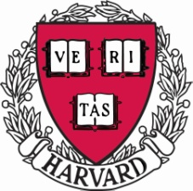
HARVARD PRIZE BOOK AWARD NOMINATION 2018

Student Name: ________________________________________________________________
Address: ____________________________________________________________________
E-mail Address: ___________________________ Telephone Number: ___________________
School Name: ________________________________________________________________
School Address: ______________________________________________________________
School E-mail: ____________________________ School Telephone: ____________________
Name of person making recommendation: __________________________________________
Relationship to Student (teacher, counselor, etc.): ____________________________________

- Academic – Please discuss this student’s academic potential: love of learning, intellectual curiosity and originality, and performance in the first three years of high school. Is there evidence of original work such as writing, poetry, mathematical or scientific research? Are there unusual factors such as language or economic opportunity that might have affected the student’s performance? Has the student won any academic awards?
- Extracurricular – Please describe the full extent of the student's commitment to life outside the classroom, such as sports, the arts, community involvement, or family or work commitments. Does the student appear to have a genuine commitment and leadership role? Has the student received international, national or local recognition?
- Personal Qualities – Can you give specific examples of this student’s maturity, character, leadership, self-confidence, warmth of personality, sense of humor, energy, concern for others, grace under pressure? Are there unusual factors or challenges the student has faced?
- English – Will this student’s command of the English language allow him/her to follow lectures, read and write extensively, and converse near fluently upon arriving in Cambridge?
Please forward your nomination to Lidija Ortloff at hccroatia@post.harvard.edu. You may nominate one student from your school. PLEASE DO NOT ALLOW STUDENTS TO SUBMIT THEIR OWN NOMINATIONS.

